Damselflies

**Introduction**

Damselflies are predatory insects of the suborder Zygoptera that reside near freshwater habitats. They are closely related to dragonflies and are similar in their reproduction, life cycle stages, frequent sexual dimorphism and aggressive male competition, though are smaller and less agile, with wings that fold against their bodies when at rest as opposed to dragonflies which hold their wings out and away from their bodies. As less adept fliers, they hunt mostly by picking sitting prey off of low vegetation, rather than catching aerial prey as dragonflies do. The data in this study includes two species of Calopteryx demoiselle damselflies, the banded demoiselle *Calopteryx splendens* and the beautiful demoiselle *Calopteryx virgo*, collected from a field monitoring project in Sweden. Both *C. splendens* and *C. virgo* are large damselflies and are sexually dimorphic in coloration, where females have translucent wings and greenish bronze bodies while males have bright metallic blue-green and pigmented wings. While *C. virgo* males have almost completely pigmented wings, *C. splendens* males have wing spots that vary in size and are considered a target of sexual selection. The data was collected from a single population repeatedly over summer months (June and July) for five consecutive years (from 2011 to 2015). The data contains several morphological traits (linear measurements of body, abdomen, thorax, and wing), a trait that is considered to be a target of sexual selection (forewing patch length and width, measured only in C. splendens), and two variables related to fitness (copulation status: a proxy for mating success and lifespan: a proxy for longevity).

The goal of this analysis is to... We hypothesize that...

**Methods**

Therefore, a mixed effect model with season and density as random effects, and age, mass, and sex as fixed effects was ultimately determined to be the final model with most explanatory power.

**Results**

The mean horn length in our data set was 364 ± 88 mm. Horn length was slightly higher for males (384 ± 87 mm) than females (338 ± 82 mm) but mean horn length did not significantly differ at high and low densities (356 ± 97 mm at high density, and 371 ± 76 mm at low density).

The formula of our determined model to predict horn length was:

hornT ~ age * mass + sex + (1 | season + density)

The parameter estimates confirmed that age, sex, and body mass were the strongest predictors of horn length (See Table 1), where βage = 46.56 ± 1.01 mm/year, βmass = 14.03 ± 0.24 mm/kg, βsex = 39.87 ± 1.67 mm (female to male). Body mass explained the greatest proportion of variance (35.4%), followed by age (26.2%), and sex (15.1%). The random effects of season and density also explained a sizable proportion of the variance (14.5% and 12.7%, respectively).

**Conclusion**

The greatest predictor of

Future analysis could improve by

Appendix

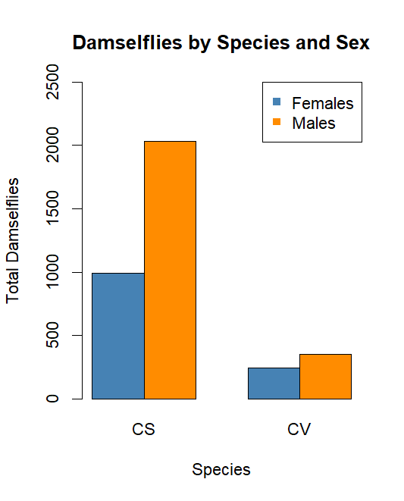

Figure

Far more C. splendens were captured than C. virgo and more than twice as many C. splendens males than C. splendens females.

|  |  |  |  |  |
| --- | --- | --- | --- | --- |
| **Table 1. Mixed effect model summary** | | | |  |
| Formula: hornT ~ age * mass + sex + (1 | season + density) | | | |  |
| **Fixed effects** | **Estimate** | **Std. Error** | **R2 (M)** | **R2 (C)** |
| (Intercept) | -1.12000 | 7.34660 | --- | --- |
| Age | 46.56103 | 1.10164 | 0.2617 | 0.2374 |
| Mass | 14.03264 | 0.23892 | 0.3539 | 0.3143 |
| SexM | 39.86516 | 1.66785 | 0.1505 | 0.1468 |
| Age:Mass | -1.62995 | 0.04805 | 0.1128 | 0.1079 |
| **Random effects** | **Variance** | **Std. Dev** |  |  |
| Season (Intercept) | 144.7 | 12.030 | 0.1165 | 0.1451 |
| Density (Intercept) | 54.6 | 7.389 | 0.1150 | 0.1270 |
| Residual | 2319.2 | 48.158 | --- | --- |

Estimates of mixed effect model where estimates are the regression coefficient (β) or the slope on the effect: Horn Length (hornT) given in mm. Sex is set relative to male (SexM) and density is set relative to low density. Percent variance explained is given by marginal R2 (M) and conditional R2 (C). Sample size n = 4,394.

Code can be found in Github repository linked below:

<https://github.com/mtindall69/bios14/tree/damselfly-final>

References